Title :- Placement Management System
(using Node.js, Express.js, MongoDB and Postman)

Objective :-
To develop a backend-based Placement Management System that manages Students, Departments, Staff, and Companies using REST APIs. The project demonstrates CRUD operations and database relationships using MongoDB and Mongoose.

Outcome :-
Successfully implemented:
- Student Management Module
- Department Management Module
- Staff Management Module
- Company Management Module
- CRUD Operations (Create, Read, Update, Delete)
- One-to-Many Relationship (Department → Students)
- Many-to-Many Relationship (Students ↔ Companies)
- API Testing using Postman

Tools and Technologies Used :-
Category | Technology
Backend Runtime | Node.js
Backend Framework | Express.js 5.2.1
Database | MongoDB
ODM | Mongoose 9.7.0
API Testing | Postman
Code Editor | Visual Studio Code
Version Control | Git & GitHub
Environment Variables | Dotenv 17.4.2
Cross-Origin Support | CORS 2.8.6
Development Server | Nodemon 3.1.14

Output Screenshots :-
Project Structure :-
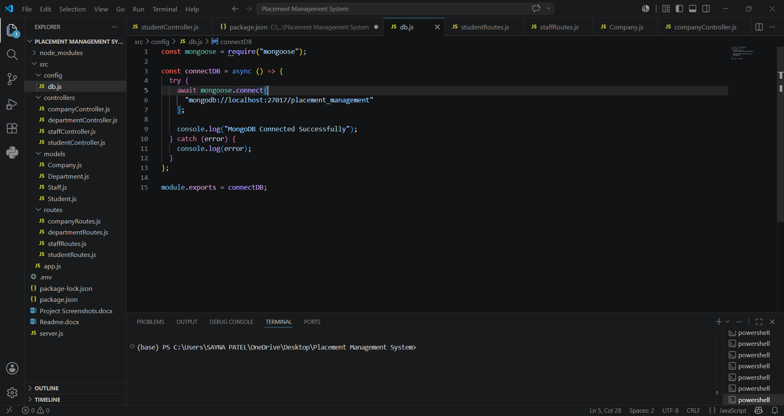
MongoDB Connected :-
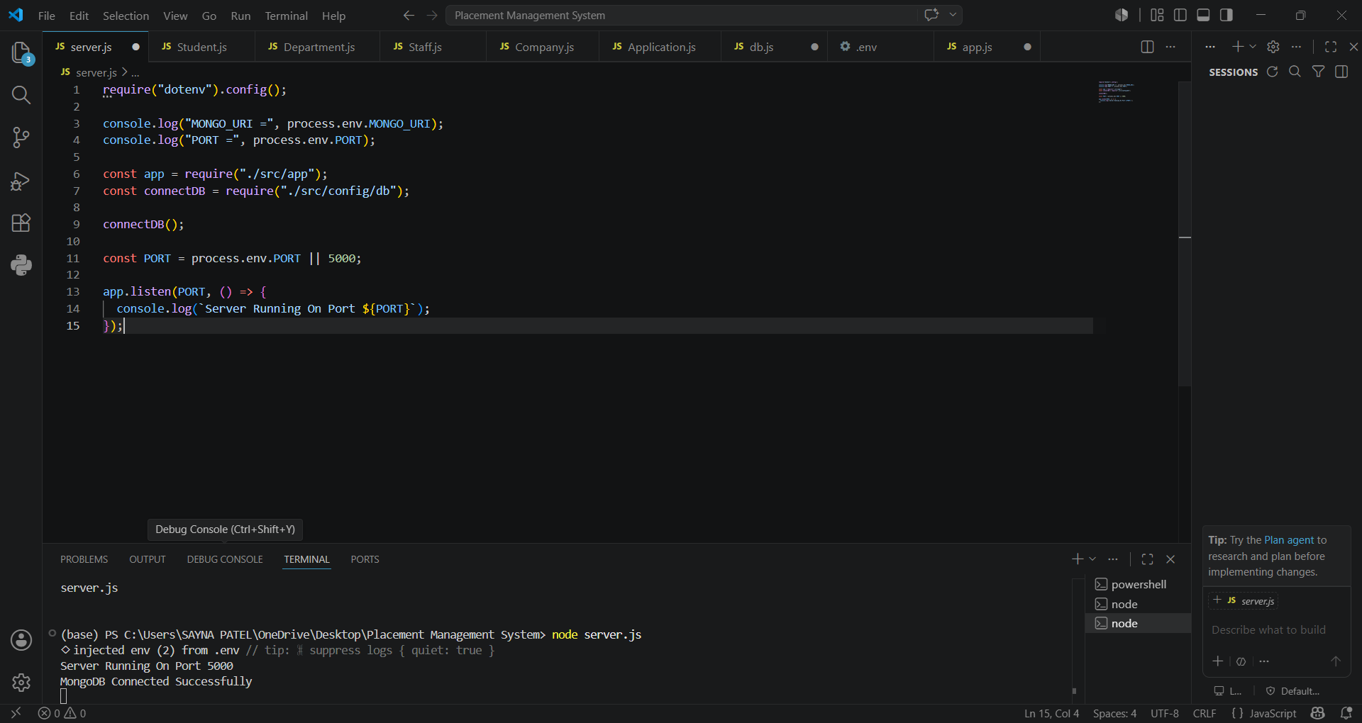
CRUD Operations :-
Student (POST)
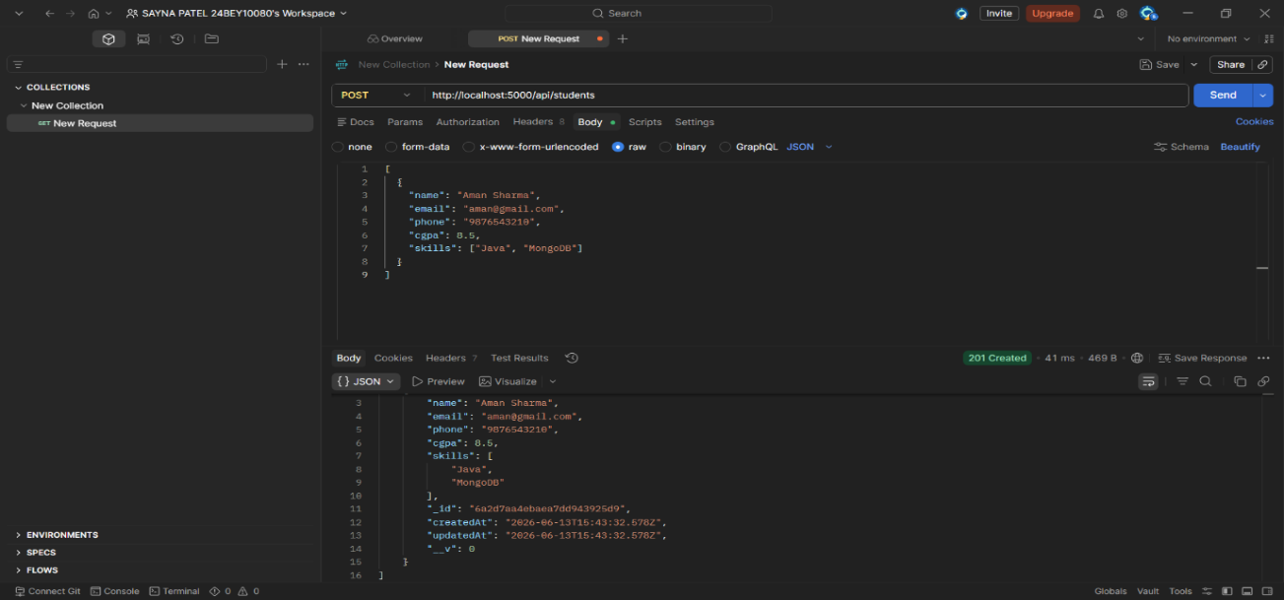
Student (GET)
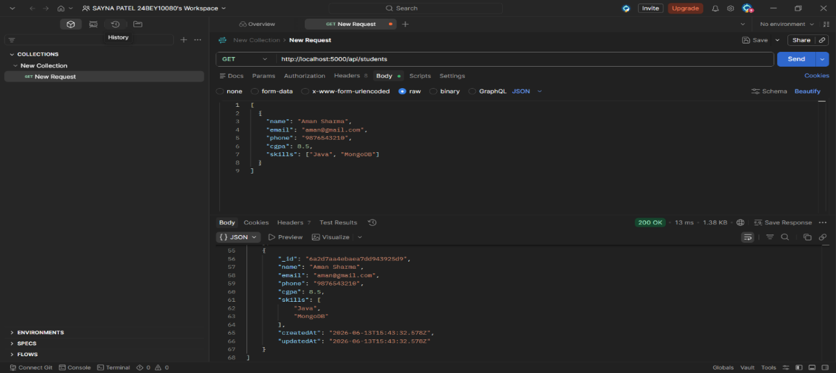
Student (PUT)
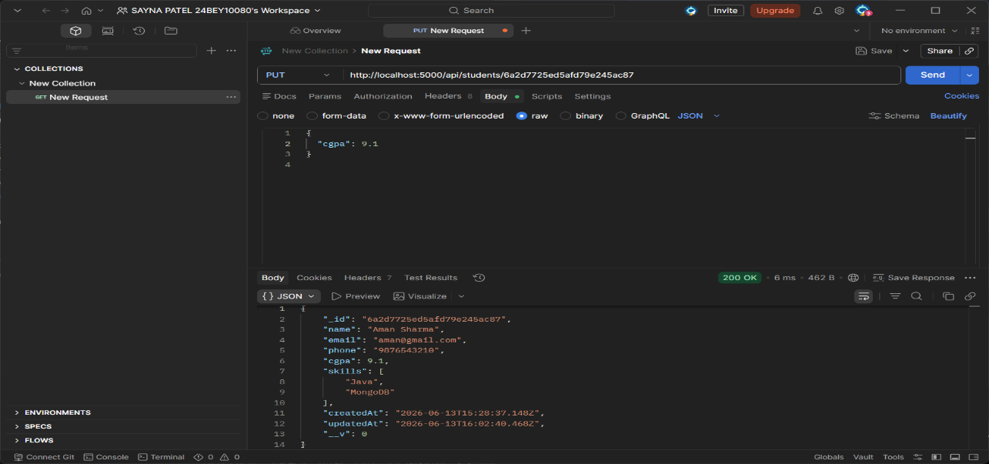
Student (DELETE)
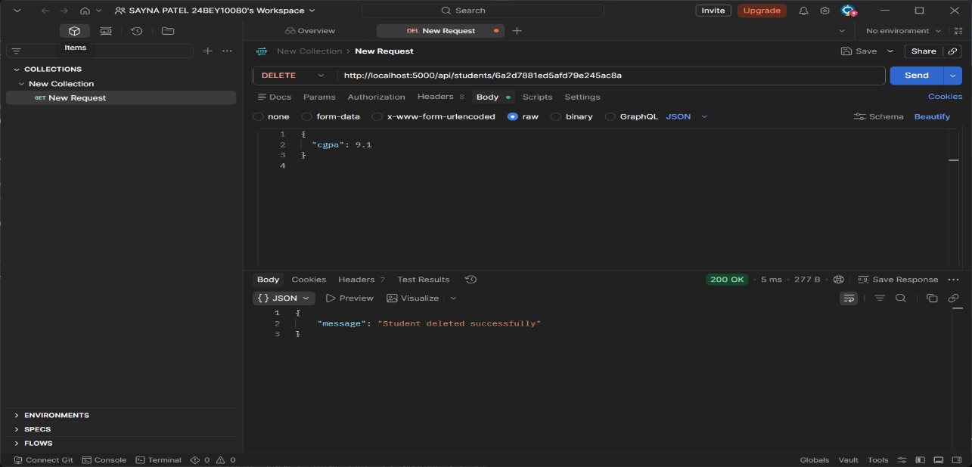
Department (POST)
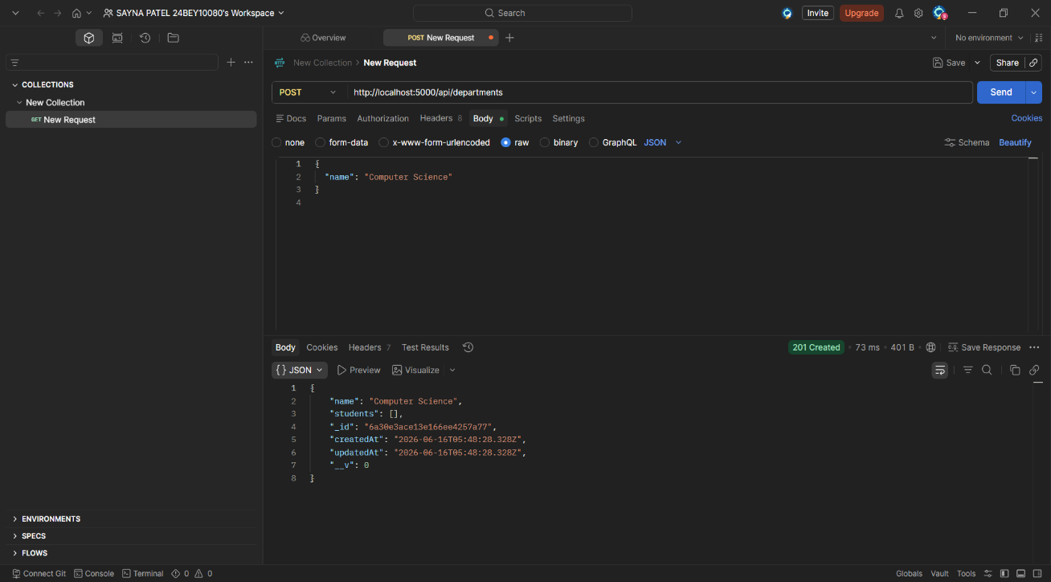
Department (GET)
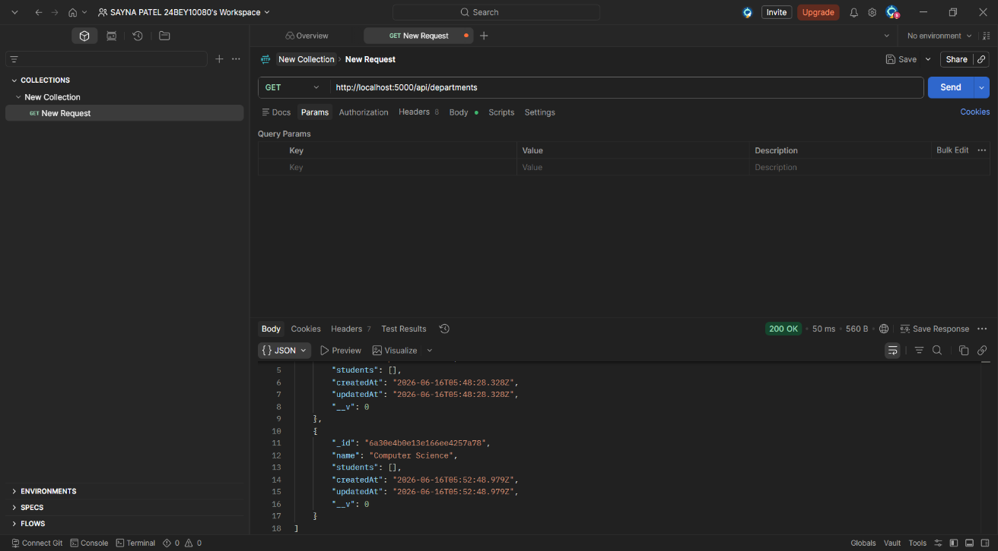
Department (PUT)
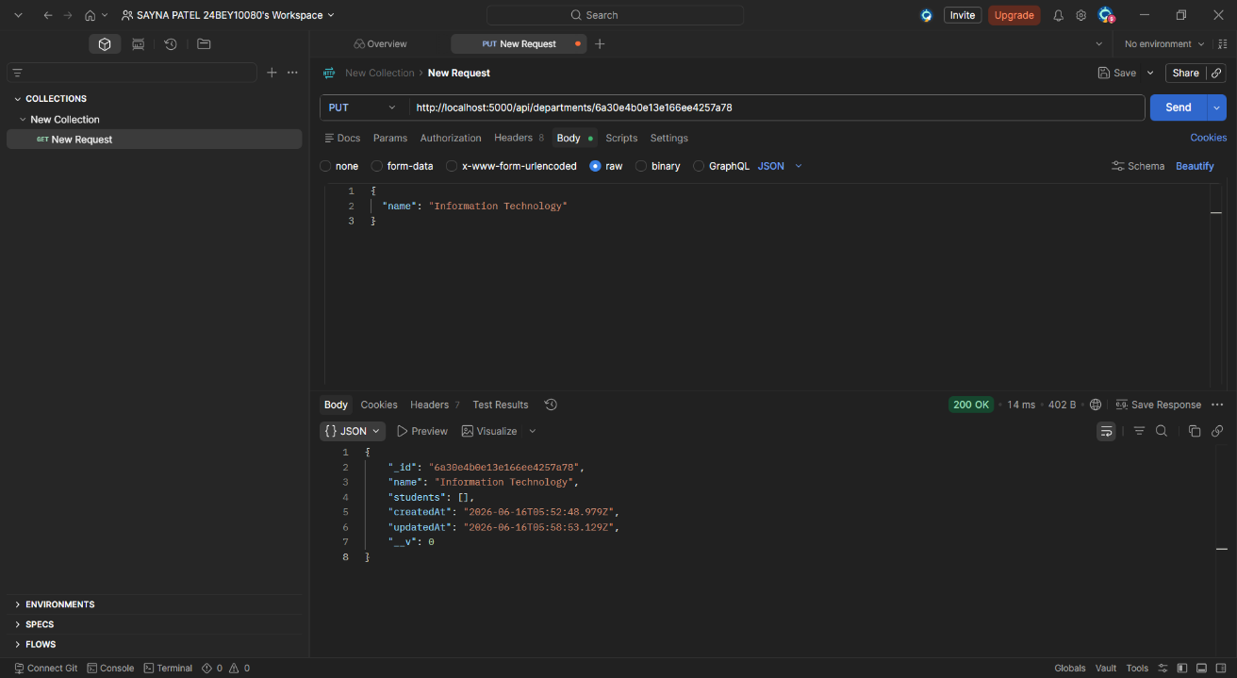
Department (DELETE)
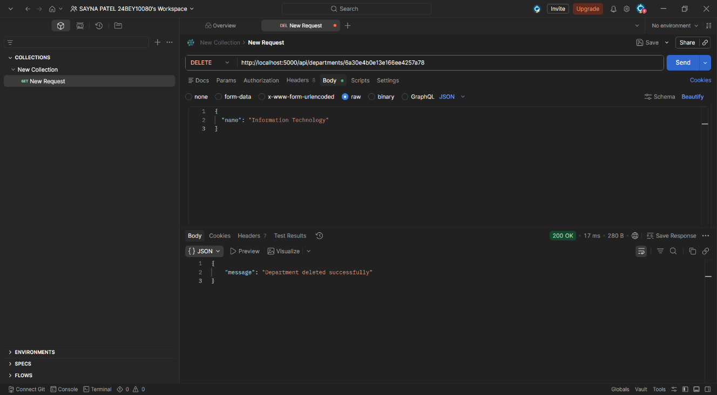
Staff (POST)
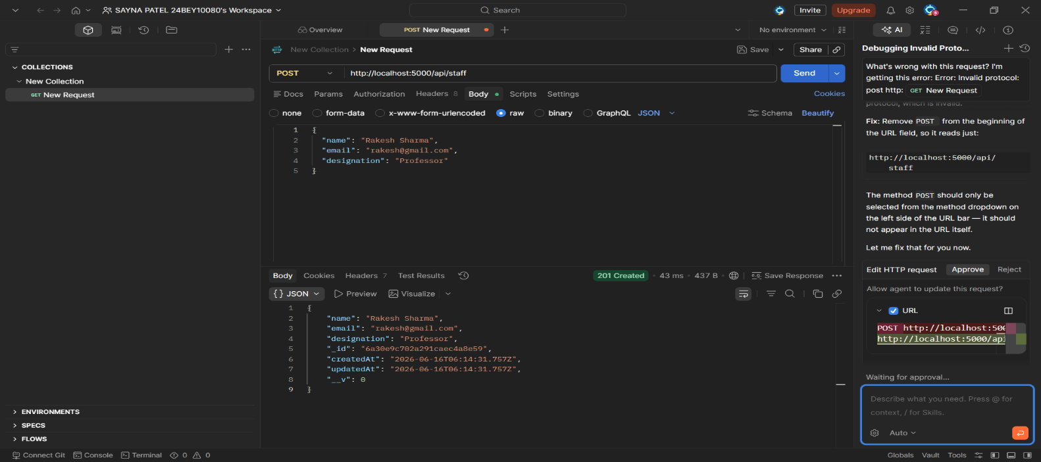
Staff (GET)
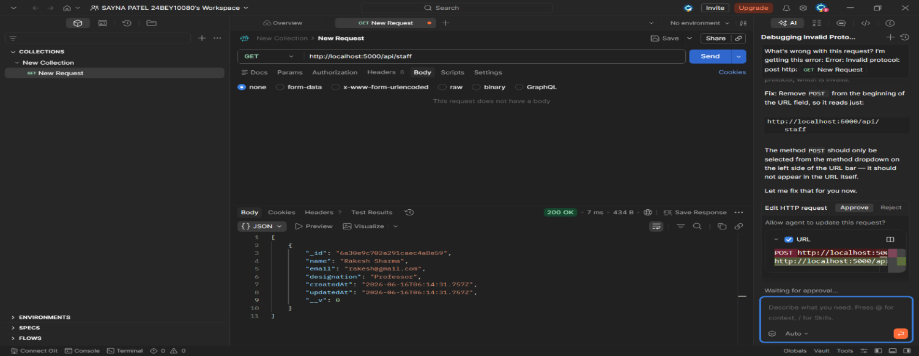
Staff (PUT)
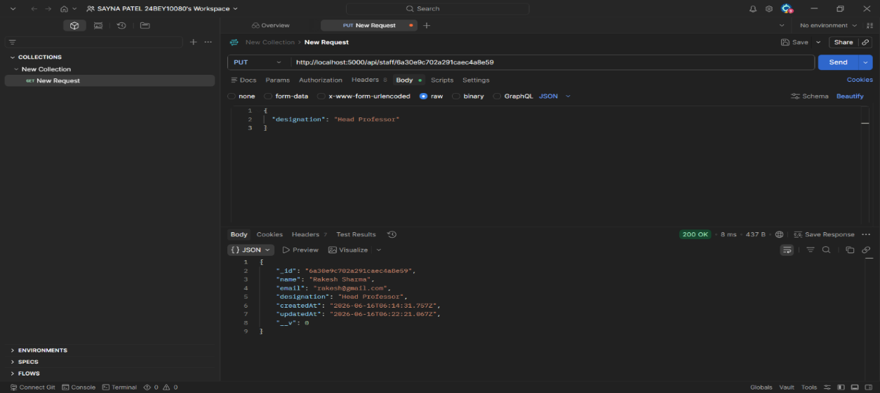
Staff (DELETE)
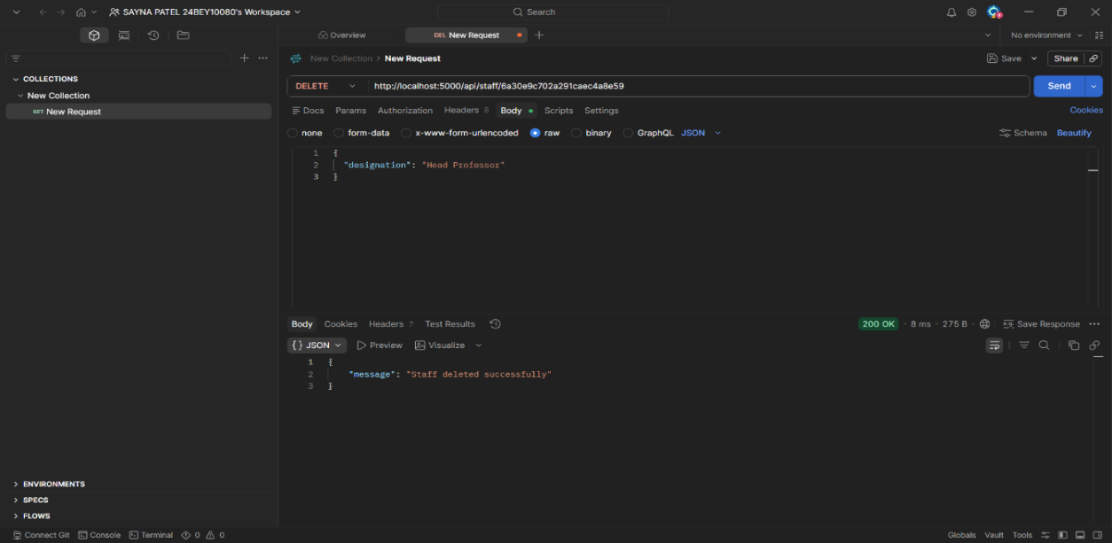
Company (POST)
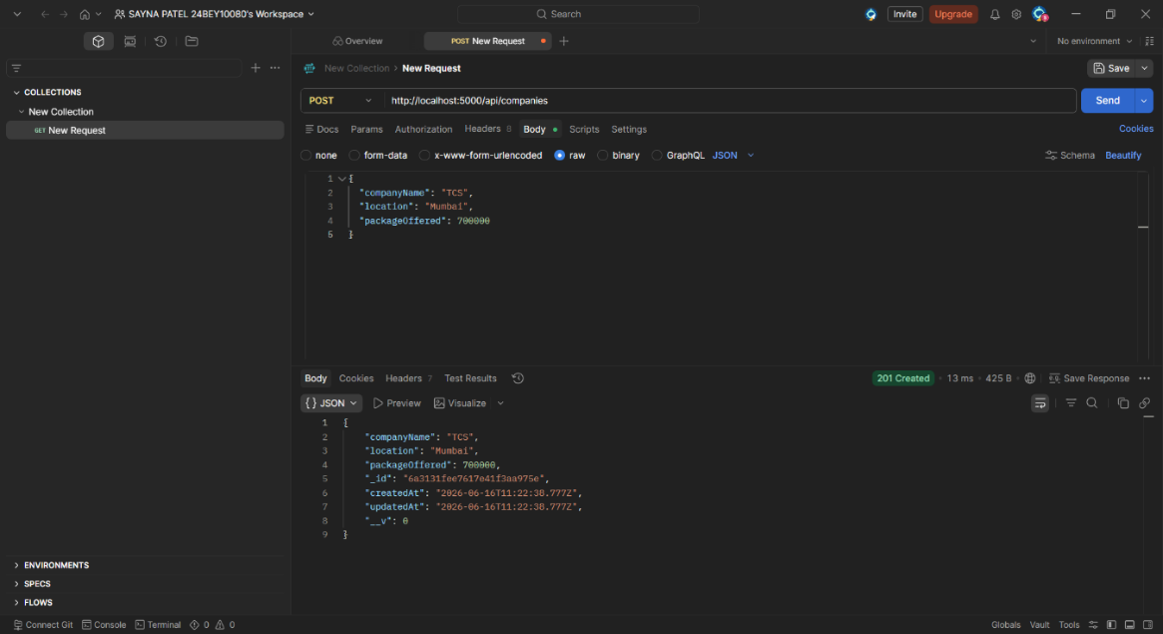
Company (GET)
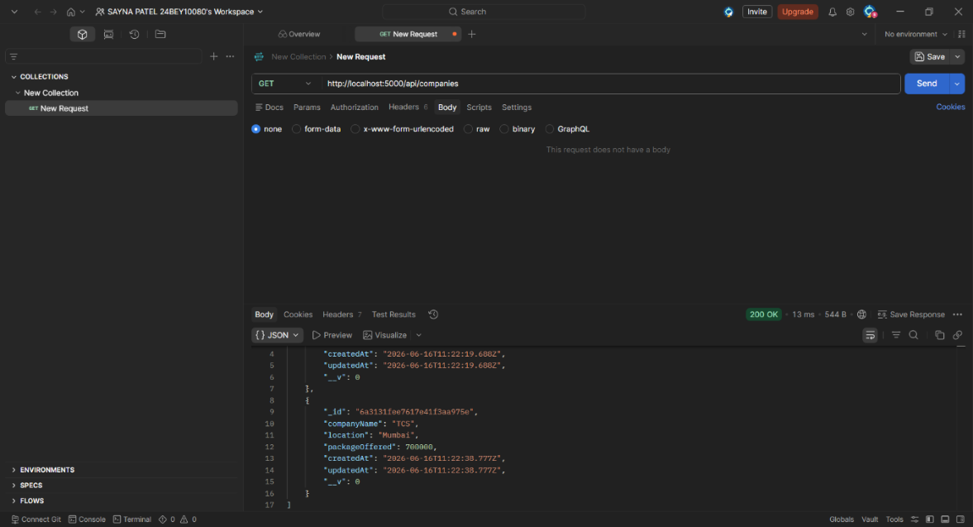
Company (PUT)
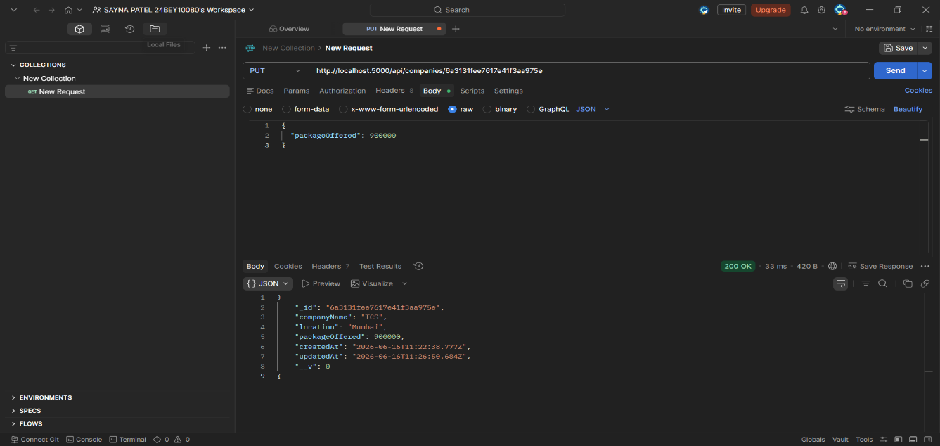
Company (DELETE)
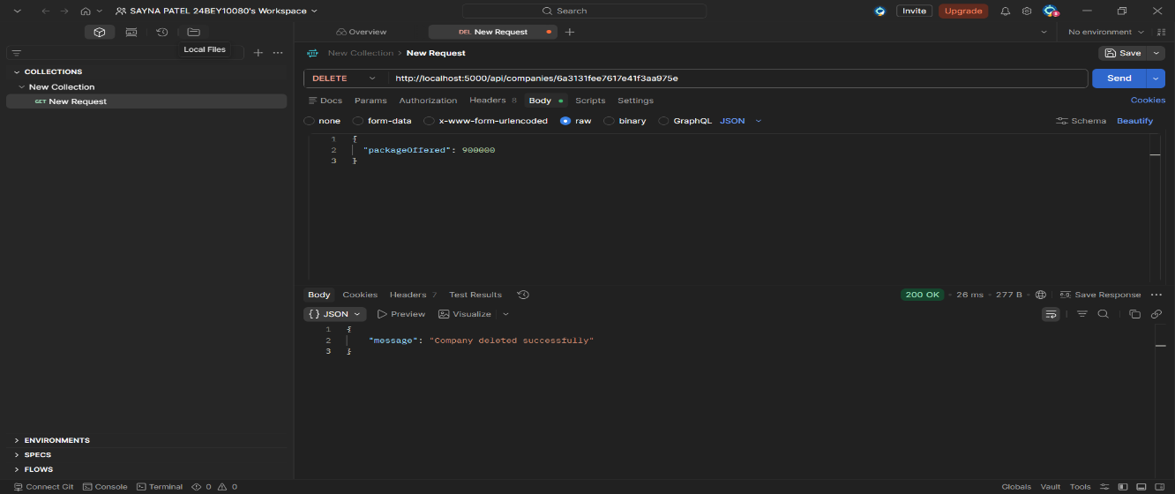

Mappings :-
One Department → Many Students (One To Many Mapping)
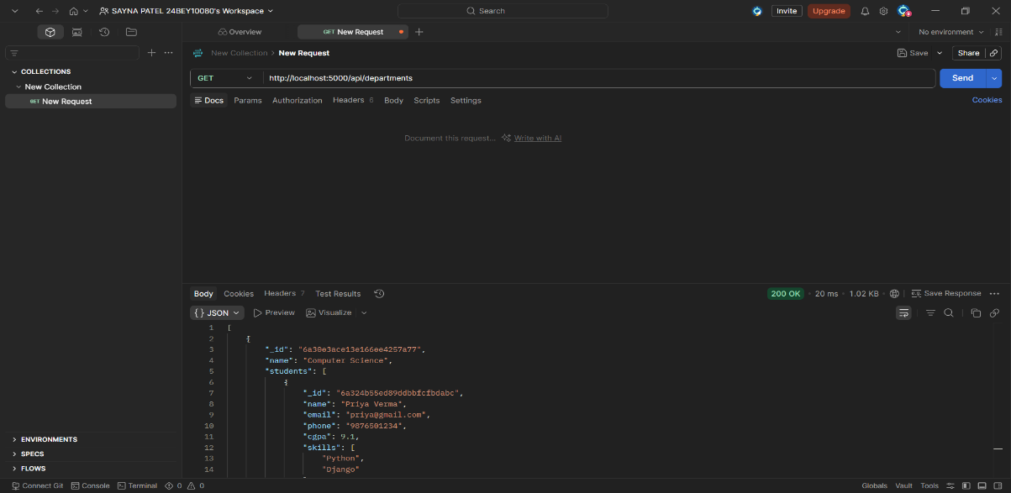
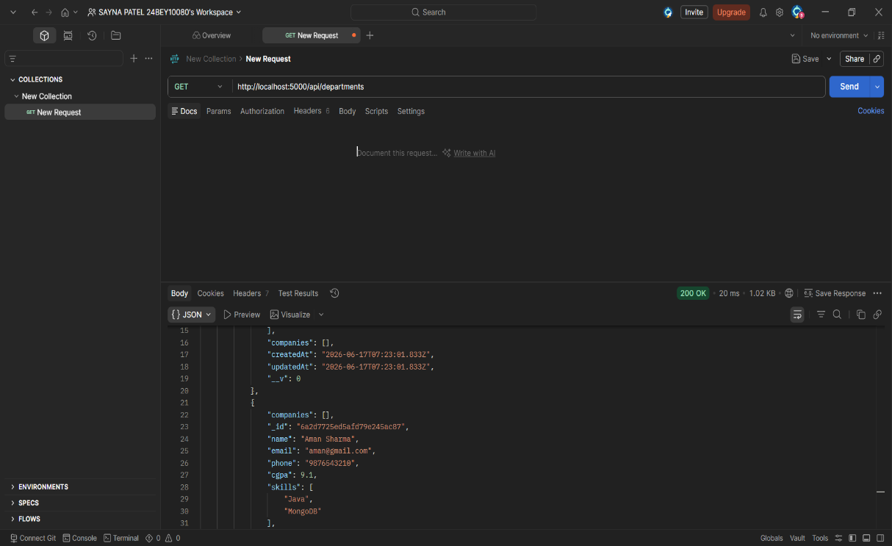
Many Students ↔ Many Companies (Many To Many Mapping )
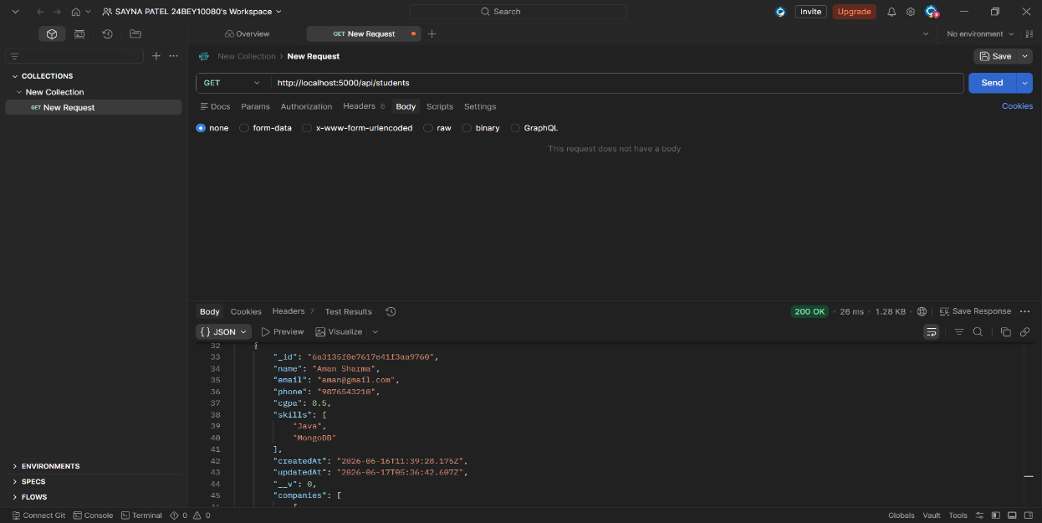
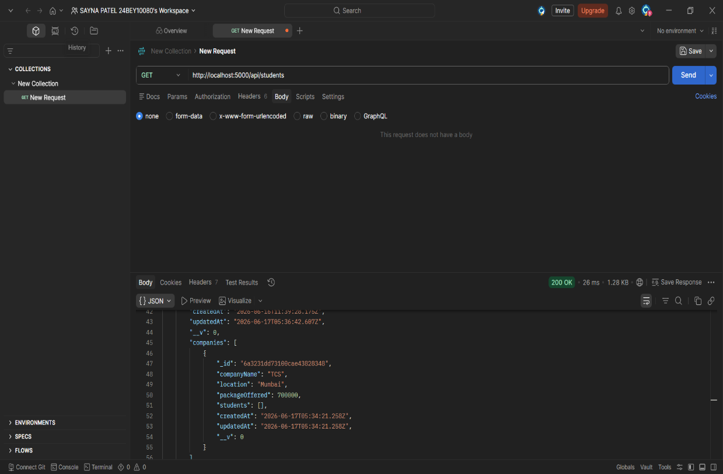

MongoDB Collections :-
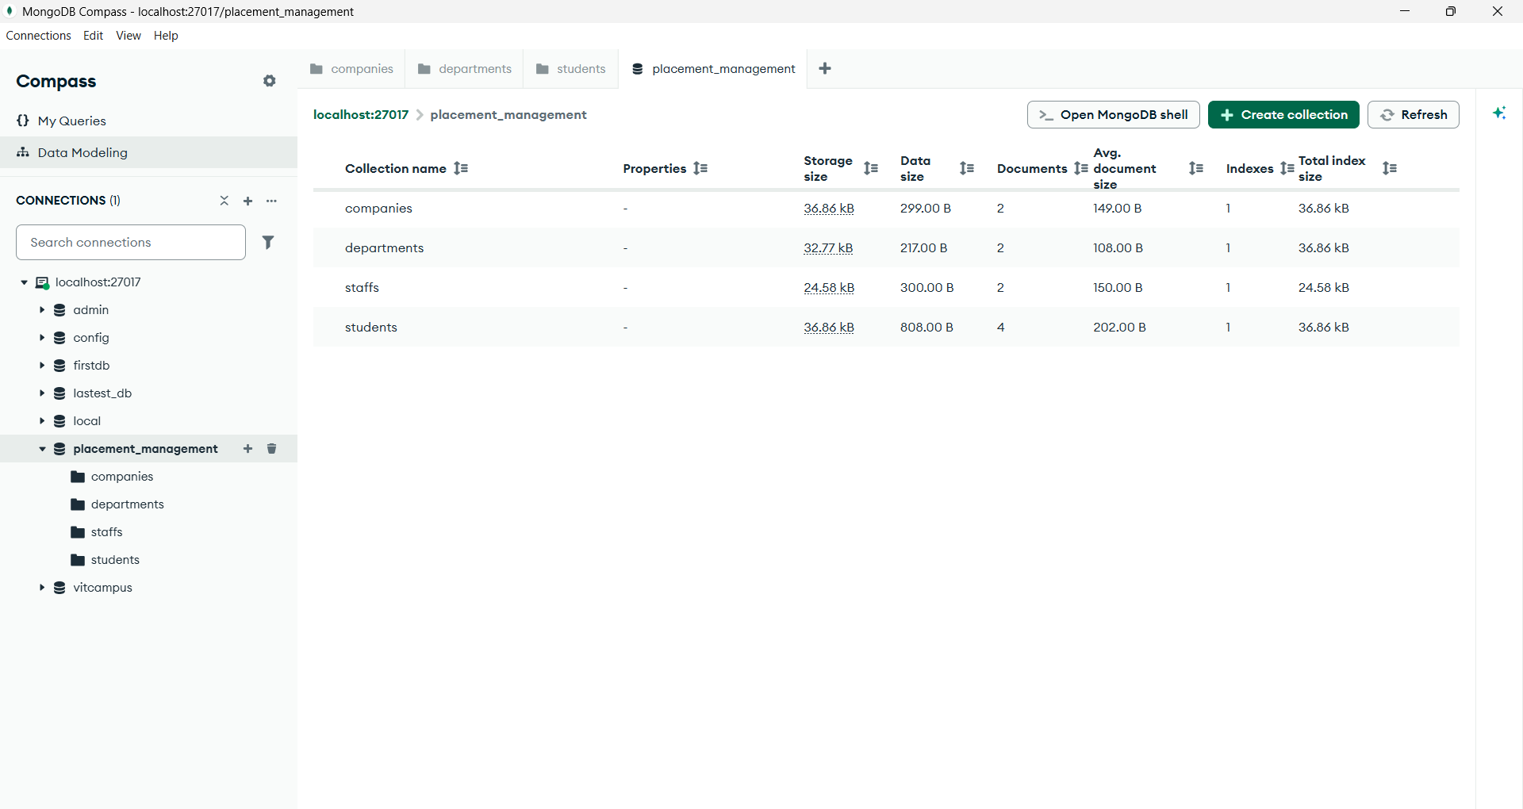
Students
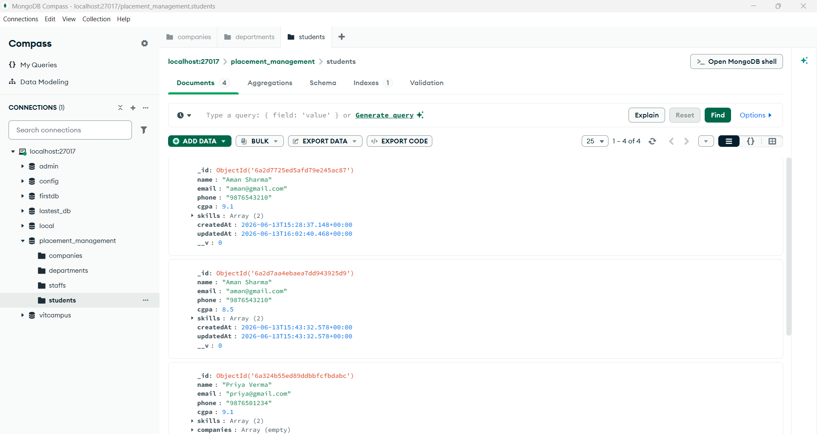
Staffs
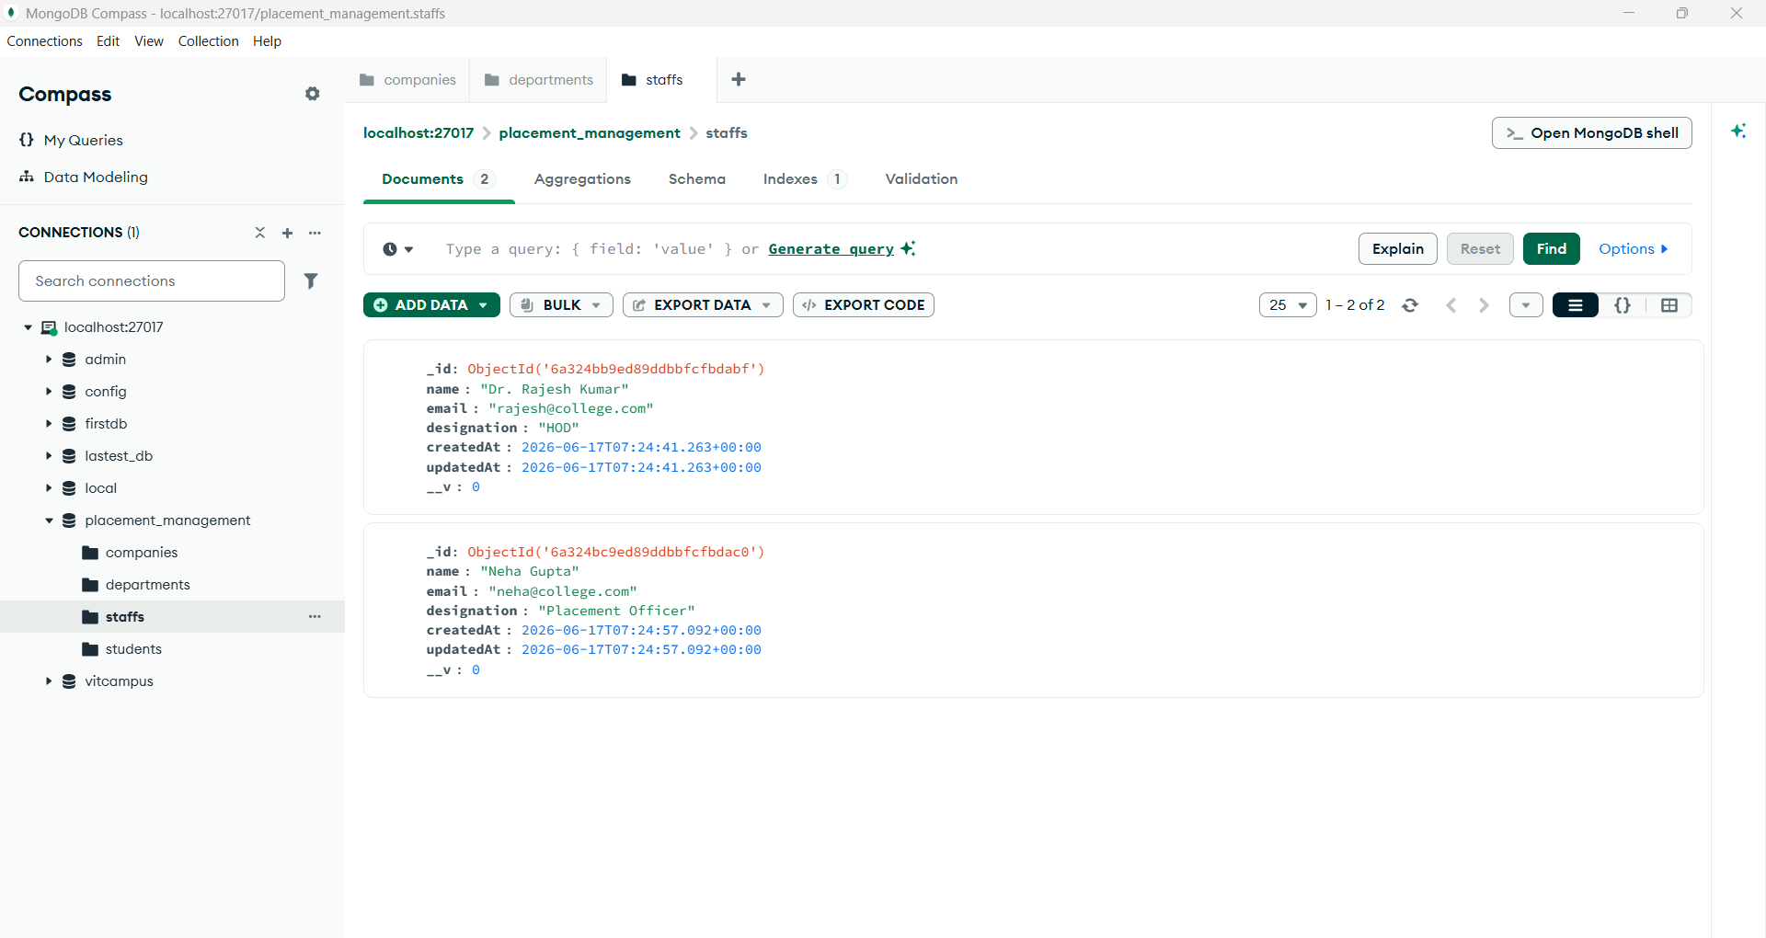
Departments
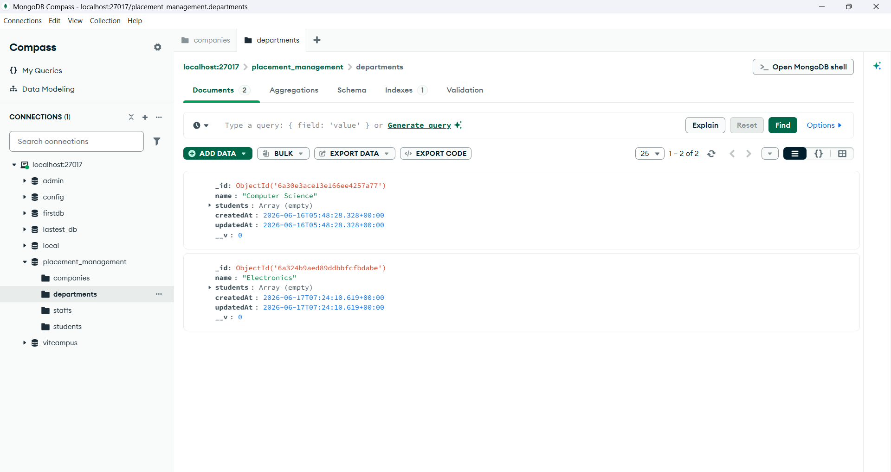
Companies
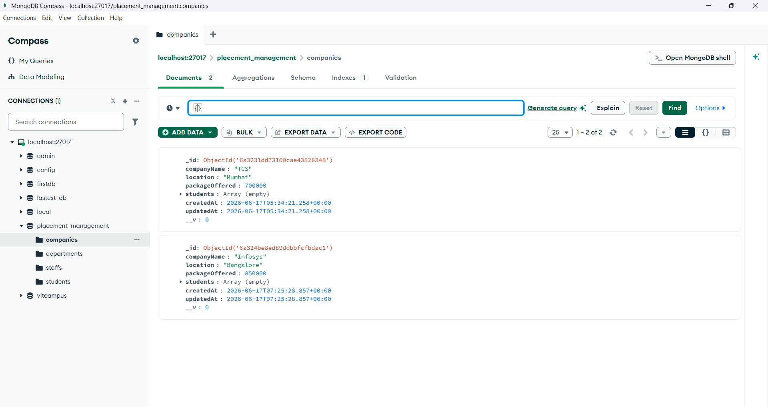

Summary :-
The Placement Management System is a backend-based application developed using Node.js, Express.js, and MongoDB. The system manages Students, Departments, Staff, and Companies through RESTful APIs. CRUD operations were implemented for all entities and tested using Postman. Database relationships including One-to-Many, Many-to-One, and Many-to-Many mappings were established using MongoDB ObjectId references and Mongoose populate() functionality.

Conclusion :-
The Placement Management System successfully fulfills all project requirements by implementing database connectivity, CRUD operations, API testing, and entity relationships. The project demonstrates practical backend development concepts such as REST APIs, MongoDB integration, schema design, and relationship mapping, making it a scalable foundation for a real-world placement management application.

